**SMART ENERGY EFFICIENT HOME AUTOMATION SYSTEM USING IOT**

Anubhav Guptabhaya1, Bareddy Suma Reddy2, Anirudh kumar mahato3, Asst. Prof. Apoorva S5.

Student, Dept. of Computer Science & Engineering, SJC Institute of Technology, Karnataka, India1

Student, Dept. of Computer Science & Engineering, SJC Institute of Technology, Karnataka, India2

Student, Dept. of Computer Science & Engineering, SJC Institute of Technology, Karnataka, India3

Asst. Prof. Dept. of Computer Science & Engineering, SJC Institute of Technology, Karnataka, India5

***Abstract-*** *Internet of Things (IoT) is an increase in the current Internet infrastructure to communicate, connect and network between different machines and physical items also known as "Things”. Because of the internet's accessibility everywhere, advancement in IoT-based implementation has become the state-of-the-art technology among researchers. In this cutting-edge technology, IoT-based and android-based systems have become more user-friendly. It proposes a intelligent energy efficient home automation scheme capable of accessing and controlling home equipment from all over the globe. The Internet connectivity module for this scheme is connected to the home system's primary supply unit that can be accessed via the Internet. The static IP address will be used for wireless connectivity. Home automation is based on a multimodal implementation that can be operated using the user's voice recognition command using the Google Assistant or an application based on the internet. The primary goal of this job is therefore to make it smart.*

***Keywords—****Home Automation, Relay, Internet of Things (IoT), Google Assistant, Voice Control, Smartphone****.***

1. **INTRODUCTION**

Technology enhancement facilitates the daily life of humans with the assistance of newly advanced smart systems. Because of the fast growth of internet technology and intelligent. Embedded systems, individuals are more interested in using the internet to monitor and observe various device kinds. Internet of things (IoT) creates a innovative evolution of the technology world with a new era of mature intelligence computing. IoT can be defined as the connection to the internet between many types of devices, such as smart phones, personal computers and tablets, which introduces the very new kind of communication between things and people and between things as well. IoT's main objective is to regulate all types of electrical objects or devices around us in a simpler, evocative and smoother way. Human-machine interaction (HMI) has become more realistic in everyday life as technology advances. HMI study today moved one step ahead and switched to the Internet, earlier used for communication and now used for stuff, i.e. IoT (Internet of Things).

The objective of this implementation is to link everything that can be connected via the Internet that can be accessible from anywhere. Although we have received tremendous technological enhancement, power consumption is still one of the world's biggest issues. According to the study, ICT alone utilizes 4.7 percent of the world's energy, which is probable to increase to 10 percent as reported. India has a share of approximately 17% of the world's population with restricted power resources and a share of approximately 0.6%, 0.4% and 7% respectively of world gas, petroleum and coal reserves. In India, however, in the last five years (for the period 2009-2014), electricity consumption due to ICT use has increased from 24 TWh to 31 TWh. This led in approximately 6.5 percent electricity consumption in 2015. The fundamental purpose of this project. We suggested the intelligent, energy-efficient home automation scheme using IoT to save power consumption. Thus, the purpose of this study is to save energy usage (reduction of electricity bills) while providing the safety and security of home equipment.

Command. So, when people would arrive home, they would find the room temperature, the bath water adjusted to their suitable preferences, and they could relax right away and feel cozier and rather, feel homelier. Human assistants like housekeepers were a way for millionaires to keep up their homes in the past. Even now when technology is handy enough only the well to do people of the society are blessed with these new smart home devices, as these devices costs are a bit high. However, not everyone is wealthy enough to be able to afford a human assistant, or some smart home kit. Hence, the need for finding an inexpensive and smart assistant for normal families keeps growing. This paper proposes such inexpensive system. It uses the Google Assistant, the IFTTT application, the Blynk application and the NodeMCU microcontroller as the major components along with a relay board comprising of 4/8 relays along with ULN 2803 IC. Natural language voice is used to give commands to the Google Assistant. All of the components are connected over the internet using WiFi which puts this system under the IoT.

Moreover, it would be better if everything such as warming bath water and adjusting the room temperature were already done before they reach their home just by giving a voice.

1. **RELATED WORKS**

This section gives an overview of the related research that has been done regarding autonomous navigation for unmanned aerial vehicles with their advantages and disadvantages.

**Matthies, Larry, et.al** developed a real time stereo vision system that uses Data cube MV-200 and a 68040 CPU board to sense terrain geometry and composition underday, night and low visibility conditions. It provides sufficient quality of the range data and detect obstacles during off-road autonomous navigation and work in a limited range. But stereo still considered too computationally expensive for unmanned ground vehicle.

**Maria T.et.al**presented a paper in whicha dynamic visual attention method used to segment the scene into moving objects-vehicles and pedestrians-and background, without using a reference image or modeling the background. Its disadvantageis that parameter this parameter tuning does not depend on each different situation stored in a video sequence taken from the camera, but only on the predefined attention focuses and also this method model used to monitor static environments

**Massimo Bertozzi.et.al** proposed a terromax vehicle which could move autonomously only up to 68kmph but it can’t work during the night and its performance is not impressive because of vehicle size and height.

**Durst.et.al**authors proposed a new environment called Autonomous Navigation Virtual Environment Laboratory (ANVEL). It uses video game technology and physics-based modeling techniques to provide an M&S toolkit that is intuitive, interactive, and physically meaningful for unmanned ground vehicle but itmainly operates during off road navigation and UGV can detect and avoid obstacles in static environment.

**Goodrich,m., cooper,J.L.,adams,J.,Humphrey,c.,Zeeman,R and buss,B.**presented a paper in which he described- Wilderness Search and Rescue can benefit from aerial imagery of the search area.Using results from formal analyses of the WiSAR problem domain, we summarize and discuss information flow requirements for WiSAR with an eye toward the efficient use of mUAVs to support search. Since the likely location of a missing person is key in determining the best paradigm given the circumstances, we report on preliminary efforts to model the behavior of missing persons in a given situation. Throughout the paper, we use information obtained from subject matter experts from Utah County Search and Rescue, and report experiences and “lessons learned” from a series of trials using human-robot teams to perform mock searches.

**Molina,P.,Colomina,I,**project named CLOSE-SEARCH, which stands for ’Accurate and safe Navigation UAV-based low-cost Search-And-Rescue (SAR) operations’. The main goal is to integrate a medium-size, helicopter-type Unmanned Aerial Vehicle (UAV), a thermal imaging sensor and an EGNOS-based multi-sensor navigation system, including an Autonomous Integrity Monitoring (AIM) capability, to support search operations in difficult-to-access areas and/or night operations.

1. **PROPOSED METHODOLOGY**

**Arduino IDE** - The Arduino Integrated Development Environment (IDE) is a cross-platform application (for Windows, macOS, Linux) that is written in the programming language Java. It is used to write and upload programs to Arduino compatible boards, but also, with the help of 3rd party cores, other vendor development boards. The source code for the IDE is released under the GNU General Public License, version 2. The Arduino IDE supports the languages C and C++ using special rules of code structuring. The Arduino IDE supplies a software library from the Wiring project, which provides many common input and output procedures. User-written code only requires two basic functions, for starting the sketch and the main program loop, that are compiled and linked with a program stub *main()* into an executable cyclic executive program with the GNU toolchain, also included with the IDE distribution. The Arduino IDE employs the program *avrdude* to convert the executable code into a text file in hexadecimal encoding that is loaded into the Arduino board by a loader program in the board's firmware.

Dept. of CSE, SJCIT

6

**Blynk** -Blynk was designed for the Internet of Things. It can control hardware remotely, it can display sensor data, it can store data, visualize it and do many other cool things.

There are three major components in the platform:

**Blynk App** - allows to you create amazing interfaces for your projects using various widgets we provide.

**Blynk Server** - responsible for all the communications between the smartphone and hardware. You can use our Blynk Cloud or run your [private Blynk server](https://docs.blynk.cc/#blynk-server) locally. It’s open-source, could easily handle thousands of devices and can even be launched on a Raspberry Pi.

**Blynk Libraries** - for all the popular hardware platforms - enable communication with the server and process all the incoming and out coming commands.

**Features**

* Similar API & UI for all supported hardware & devices
* Connection to the cloud using:
* WiFi
* Bluetooth and BLE
* Ethernet
* USB (Serial)
* GSM
* Set of easy-to-use Widgets
* Direct pin manipulation with no code writing
* Easy to integrate and add new functionality using virtual pins
* History data monitoring via SuperChart widget
* Device-to-Device communication using Bridge Widget
* Sending emails, tweets, push notifications, etc

**GOOGLE Assistant**

Google Assistant is an artificial intelligence-powered virtual assistant developed by Google that is primarily available on mobile and smart home devices. Unlike the company's previous virtual assistant, Google Now, the Google Assistant can engage in two-way conversations. Assistant initially debuted in May 2016 as part of Google's messaging app Allo, and its voice-activated speaker Google Home. After a period of exclusivity on

the Pixel and Pixel XL smartphones, it began to be deployed on other Android devices in February 2017, including third-party smartphones and Android Wear (now Wear OS), and was released as a standalone app on the iOS operating system in May 2017. Alongside the announcement of a software development kit in April 2017, the Assistant has been, and is being, further extended to support a large variety of devices, including cars and third party smart home appliances. The functionality of the Assistant can also be enhanced by third-party developers. Users primarily interact with the Google Assistant through natural voice, though keyboard input is also supported. In the same nature and manner as Google Now, the Assistant is able to search the Internet, schedule events and alarms, adjust hardware settings on the user's device, and show information from the user's Google account. Google has also announced that the Assistant will be able to identify objects and gather visual information through the device's camera, and support purchasing products and sending money, as well as identifying songs.

**Micro-Controller**

A microcontroller (MCU for *microcontroller unit*) is a small computer on a single metal-oxide-semiconductor (MOS) integrated circuit chip. In modern terminology, it is similar to, but less sophisticated than, a system on a chip (SoC); an SoC may include a microcontroller as one of its components. A microcontroller contains one or more CPUs (processor cores) along with memory and programmable input/output peripherals. Program memory in the form of ferroelectric RAM, NOR flash or OTP ROM is also often included on chip, as well as a small amount of RAM. Microcontrollers are designed for embedded applications, in contrast to the microprocessors used in personal computers or other general purpose applications consisting of various discrete chips. Microcontrollers are used in automatically controlled products and devices, such as automobile engine control systems, implantable medical devices, remote controls, office machines, appliances, power tools, toys and other embedded systems.

1. **FLOW CHART**

# **Capture1**

1. **HARDWARE RESULTS**

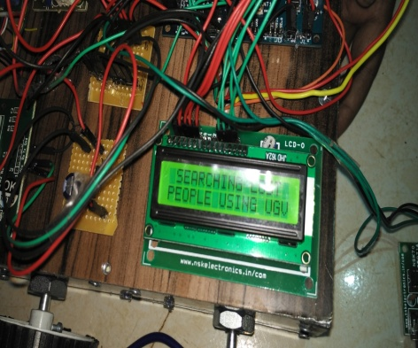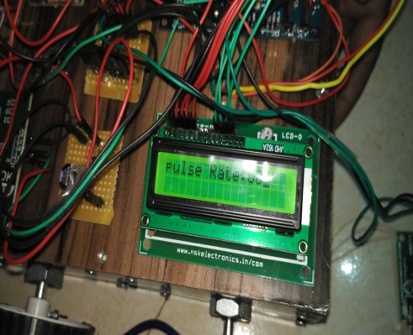

**Fig: - Looking for the peopleFig: - Measuring pulse rate**

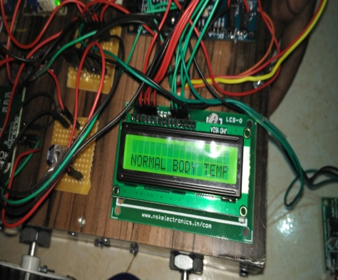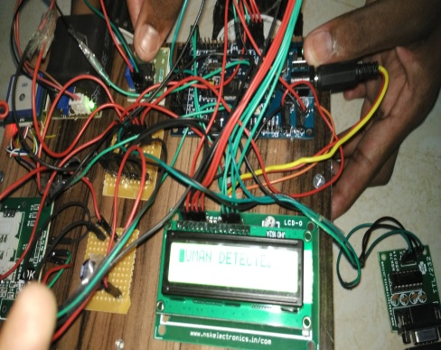

**Fig: -Showing body temperature Fig: - Message sent “human detected”**

1. **CONCLUSION**

In this paper, we have presented the step-by-step procedure of smart home automation controller unit. With the help of the design control unit, home appliance can be converted into a smart and intelligent device using IoT. The working of the proposed model was experimentally shown with help of connecting the three bulbs. Proposed system has two advantages.

First, using the IoT connectivity, we can monitor and access our smart home easily from anywhere, which will definitely will prove to be energy efficient.

Secondly, it act has a helping hand for the old age and differently abled person. For future work we would like to add up more controlling units that can make our smart home more intelligent that can be practically deployed in the real time situation

1. **REFERENCES**

[1] P. Damacharla, A. Y. Javaid, J. J. Gallimore and V. K. Devabhaktuni, ”Common Metrics to Benchmark Human-Machine Teams (HMT): A Review,” in IEEE Access, vol. 6, pp. 38637-38655, 2018.

[2] O. Benderius, C. Berger and V. Malmsten Lundgren, ”The Best Rated HumanMachine Interface Design for Autonomous Vehicles in the 2016 Grand Cooperative Driving Challenge,” in IEEE Transactions on Intelligent Transportation Systems, vol. 19, no. 4, pp. 1302-1307, April 2018

[3] Z. Xu, R. Wang, X. Yue, T. Liu, C. Chen and S. Fang, ”FaceME: Face-to-Machine Proximity Estimation Based on RSSI Difference for Mobile Industrial HumanMachine Interaction,” in IEEE Transactions on Industrial Informatics, vol. 14, no. 8, pp. 3547-3558, Aug. 2018.

[4] S. Ziegler, S. Nikoletsea, S. Krco, J. Rolim and J. Fernandes, ”Internet of Things and crowd sourcing - a paradigm change for the research on the Internet of Things,” 2015 IEEE 2nd World Forum on Internet of Things (WF-IoT), Milan, 2015, pp. 395-399.

[5] J. Voas, B. Agresti and P. A. Laplante, ”A Closer Look at IoT ’s Things,” in IT Professional, vol. 20, no. 3, pp. 11-14, May./Jun. 2018.

[6] Q. F. Hassan, ”Introduction to the Internet of Things,” in Internet of Things A to Z: Technologies and Applications , IEEE, 2018.

[7] L. Atzori, A. Iera, and G. Morabito, “The internet of things: A survey,” Comput. Netw., vol. 54, no. 15, pp. 2787–2805, 2010.